**PCB Artist**

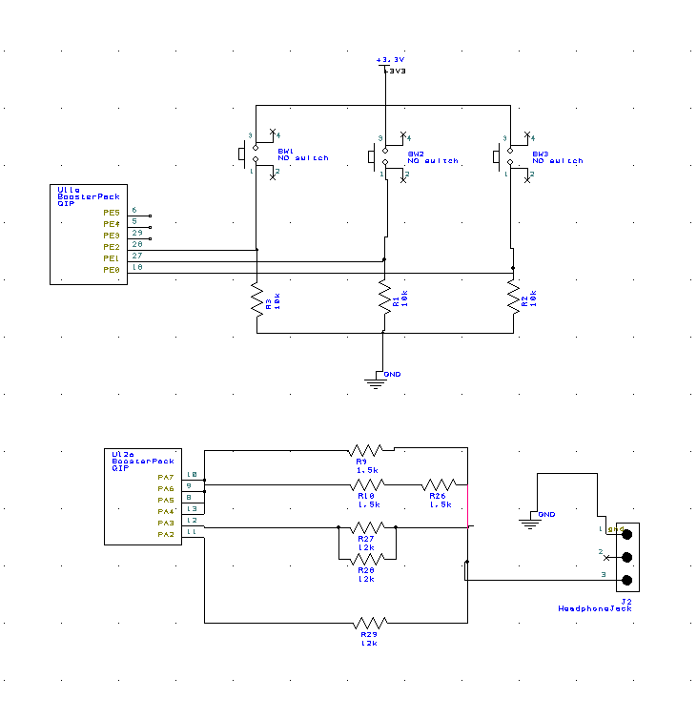

**Data Structures**

Array: SineWave

|  |
| --- |
| 0 |
| 0 |
| 0 |
| 0 |
| 1 |
| 1 |
| 2 |
| 3 |
| 5 |
| 6 |
| 7 |
| 9 |
| 11 |
| 12 |
| 13 |
| 14 |

|  |
| --- |
| 14 |
| 15 |
| 15 |
| 15 |
| 14 |
| 14 |
| 13 |
| 12 |
| 10 |
| 9 |
| 7 |
| 6 |
| 5 |
| 3 |
| 2 |
| 1 |

**Output values**

|  |  |  |
| --- | --- | --- |
| **Bits** | **Theoretical V** | **Actual V** |
| 1 | **0.22** | **0.201** |
| **2** | **0.44** | **0.412** |
| **3** | **0.66** | **0.634** |
| **4** | **0.88** | **0.842** |
| **5** | **1.10** | **0.989** |
| **6** | **1.32** | **1.123** |
| **7** | **1.54** | **1.424** |
| **8** | **1.76** | **1.681** |
| **9** | **1.98** | **1.930** |
| **10** | **2.2** | **2.125** |
| **11** | **2.42** | **2.312** |
| **12** | **2.64** | **2.468** |
| **13** | **2.86** | **2.721** |
| **14** | **3.08** | **3.012** |
| **15** | **3.3** | **3.249** |

**Resolution: 0.22 V**

**Range: 0.22V - 3.30V**

**Precision: 4 bits = 16 alternatives**

**Questions**

**When does the interrupt trigger occur?**

Whenever the current value of SysTick reaches zero.

**In which file is the interrupt vector?**

Startup.S

**List the steps that occur after the trigger occurs and before the processor executes the handler.**

The current instruction is finished, registers are pushed into stack, LR is set to 0xFFFFFFF9, IPSR is set to the interrupt number and finally, the PC is loaded with the interrupt vector.

**It looks like BX LR instruction simply moves LR into PC, how does this return from interrupt?**

As the LR is 0xFFFFFFF9, the 8 register of the stack are popped, in which R0-R3, R12, LR, PC and PSW are included returning to the original PC.

**SERVICE**



